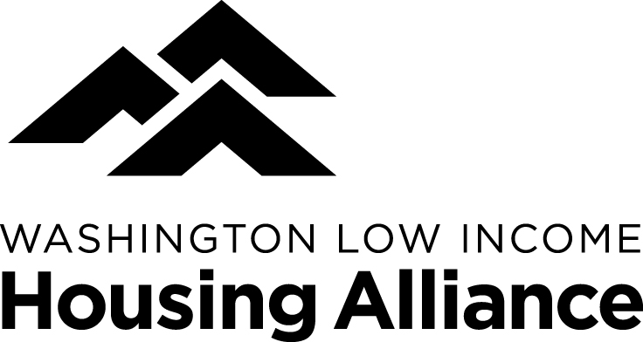
Frequently Asked Questions
About Advocacy Day

Where do we meet?
The day starts at United Churches, 110 11th Avenue SE, Olympia, WA 98501. Enter through the 11th Avenue entrance to check-in and get your scarf and packet.

Where can I park?
There is affordable street parking near United Churches and the capitol, as well as several lots on the capitol campus that are open to visitors. Those with a disabled parking permit can park in designated spots in the United Churches lot; the rest of the United Churches lot is reserved.

Do I still need to check-in if I registered in advance?
Yes, we want to know you’re here! Plus, that’s where you’ll get your materials and any important updates for the day.

What if I didn’t register in advance?
You can still register when you arrive at Advocacy Day, but you will not be guaranteed a materials folder or a lunch. If there are still lunches available after 1 pm, day-of registrants may take a lunch at that point.

I have some mobility limitations, how is Advocacy Day accessible for me?
Most events at the United Churches building will be on the main floor, which has an accessible entrance and restroom. The only activities downstairs are morning snacks, the social media workshop, and prep meetings for districts 17-33. To access those activities without using the stairs, you would have to go outside the building and around to the lower entrance. Volunteers will be on hand who can assist you with getting there, or who can bring up a beverage and a snack in the morning for you.
To get to the capitol campus from the United Churches building, you can use the free DASH shuttle that leaves every 10 minutes and stops in front of both locations.
The capitol campus buildings are ADA-compliant. At the rally on the steps of the capitol, you’re welcome to join in near the front of the rally at the base of the steps.

Do I need to make appointments with my legislators?
No, the Housing Alliance schedules meetings with your legislators that are open to all constituents. In fact, it could be overwhelming to the legislators’ staff if many Advocacy Day attendees made separate meetings, so please coordinate with our scheduler if you have a particular reason to make additional meetings that day.

How do I know when/where my legislator meetings are, and what to say at the meetings?
First, check the large legislator meetings schedule posted in the United Churches foyer. Then, attend your district group planning meeting from 9:30-10, where your District Lead will help the group coordinate the meeting agenda and speakers. Be aware that many districts have a large number of attendees and not everyone will get a chance to speak during the meeting, but your presence is still very important!

What issues will be discussed at the legislator meetings on Advocacy Day, and where can I get more info about them?
Because we are coming together around our shared concern for affordable housing and homelessness on this day, legislator meetings will focus on the bills and budget requests that make up the Housing Alliance 2017 lead legislative agenda. You can find the agenda and more on these issues at wliha.org/advocacy/state.

Is there wifi at United Churches?
Yes, but it’s limited. Presenters and others with an official need for wifi can ask for the password at the information table.

There’s a big gap between my legislator meetings, what can I do during that time?
Visiting the legislative information center on the first floor of the legislative building is a great first stop. There you can find out about hearings that you could attend, get printed information about the legislative process and your legislators, and even sign up for a tour of the capitol (depending on availability). Please also visit the governor’s office in the legislative building and leave a message of support for affordable housing if you have time. Food and beverages are also available in the Dome Deli in the legislative building or in the Pritchard cafeteria.
Is there a Lost and Found at Advocacy Day?
Yes; if you’ve lost or found an item, please inquire at/bring it to our information table, which will be at United Churches in the morning and on the 4th floor mezzanine of the Legislative Building in the afternoon.

Do I need to do anything after my legislator meetings, or is that the end of the day?
Please stop by the Housing Alliance information table on the 3rd floor of the legislative building to drop off your completed feedback form. Your legislative district lead will be reporting back from your district’s meetings with legislators, but if you have any insights from the meetings that you want to share as well, please do!

If you have any additional questions, in advance, please contact Alouise: Alouise@wliha.org, 206-442-9455 x 203, or on Advocacy Day, ask any staff member, board member, or volunteer – they’ll be wearing yellow nametags.

